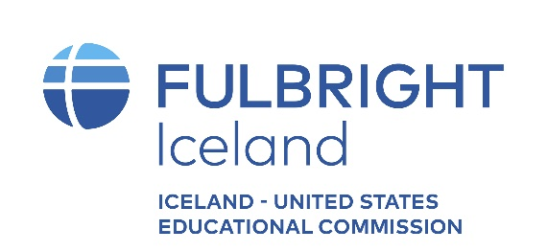

Nomination Form for the Partnership Award 2023

Name and title of nominee_________________________________________________________________

E-mail _____________________________________ Tel: _____________________________________

Reason for nomination – how does this person fulfill the award criteria? (max. 250 words)

Name, title, e-mail and telephone number of person submitting the nomination.
______________________________________ __________________________
______________________________________ __________________________
Please send this form electronically no later than 11 January, 2023 to: adviser@fulbright.is.
Please put „nomination form“ in the subject of the e-mail.
Also attach a CV or biography of the nominee, as well as any additional materials you consider pertinent.
Incomplete nominations will not be considered.

